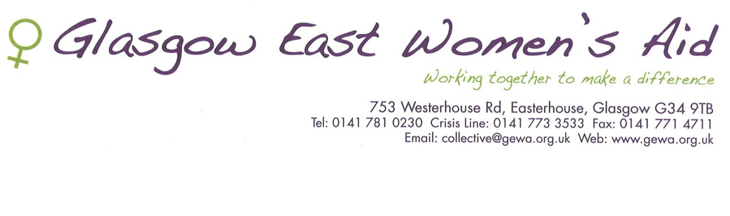

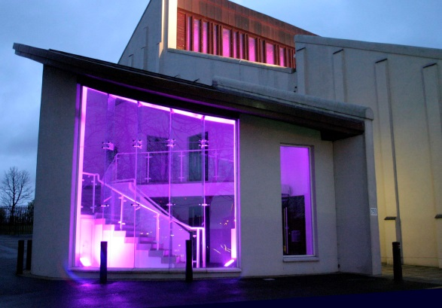

ANNUAL REPORT 2016-17

CHILDREN YOUNG PEOPLE
Children & Young People’s Service The past year has continued to be a busy one. The service has had an increase in referrals for children requiring therapeutic support to aid in their recovery from abuse. This has highlighted the growing demand for our service. Our outreach workers are Gemma and Gillian and our workers at refuge are Karen, Tricia and Agnes. Our children and young people’s service was inspected by the Care Inspectorate in 2016 and we received sixes across all areas which are the highest possible marks. Thank you to all the women, children and young people who participated in this process. We were very proud of the children and young people who joined our art group and expressed their feelings and emotions around their experiences of domestic abuse and created powerful pieces of art. It was as a result of this piece of work that the Photo Story came together for our conference. A young person who had previously used the service was able to co-facilitate the art group, assisting the younger children to express themselves. She was a fantastic role model for the other children in highlighting how her support from our children & young people’s service helped her move on and recover from domestic abuse. She used her experiences co-facilitating the group as part of her portfolio for a school project and we are so proud of her amazing confidence in being able to present the Photo Story at Gewa’s conference to an audience of 185 delegates which reflects the success of her therapeutic journey. Our final speaker was a young person who is an ex service user and gave a heartfelt presentation on his lived experience and how the support from the service had enabled him to understand his behaviours, emotions and feelings. He is now working in the social care sector and is a real success story in himself. The impact of his speech touched every delegate. A very special thank you to all of our children and young people who participated in the art group and in particular our brave and amazing speakers at the conference.

OUTINGS
Throughout the year the children and young people participated in some group outings including Ayr beach, New Lanark Heritage Centre and Sno Zone, at Braehead where they had taster sessions in snowboarding and sledging. The Children and Young People’s service continues to face insecure future funding and we hope to be able to continue offering one to one and group support as well as social outings during school holidays to children and young people in the future.

CRISIS SUPPORT
Drop in Crisis support is available 5 days a week from 9.30-3.30pm. We offer immediate support, information and advocacy, locate refuge accommodation for women. This is often the first point of contact and women are often distressed, unsure of what they want and extremely anxious about what lies ahead.

FAMILY DEVELOPMENT
The FDS has a new part-time worker in the team this year called Louise, she was originally working in the children’s service and has been a fabulous addition to the FDS using her creative skills to work now with both women and children.
The FDS uses a needs-led approach informed by service users and as a result is responsive, busy and varied. Support takes many forms with both individuals and family groups. It can involve emotional and practical support, advocacy, education around the effects and impact DA has on family members, stress reduction, confidence building, safety planning, links into community resources, managing unhelpful coping mechanisms, parenting support and support through child protection procedures and court processes.
An integral part of our funding this round was a group work programme; this included a parenting group facilitated by the Women’s Support Project(focusing on talking to your children about sexual abuse, online safety and mothering after domestic abuse), cooking on a budget with Clarity Nutrition and a weekly yoga and stress reduction class delivered by Eleanor. In addition to this Alison has used her contacts in Glasgow Life and co-facilitated a cycle group which the families have loved because it has increased their confidence, given them the opportunity to spend quality family time together and strengthen their relationships.
A Family Development worker was also involved in securing funding for GEWA’s conference called The Silent Scream which explored coercive control and often unreported abuse. Blake Stevenson have started an external evaluation of the FDS which involved staff, 19 women and 8 professionals; this has been a huge piece of work however the draft report is really positive and enables us to continue to improve our service and illustrate the value of what we do to potential funders.

FINANCE
Interestingly I found an annual report from 2000/2002 and in that this is what it said
“The reality is that with standstill funding and increasing costs – every year is more difficult. We cannot save on wages costs without cutting workers hours especially as we are dealing with five more times service users than expected. Our running costs budget is therefore squeezed year on year. The consequence of this is that the direct service to women and children suffers.”
That was 15 years ago and it’s still the same ☹ without funding GEWA would be unable to deliver and sustain the expert services we deliver.

MULTI-AGENCY
Multi-agency position is a standalone role that taps into every other existing positions within GEWA; Over the past year I have represented GEWA at various events and meetings city and nationwide to raise our organisation profile, to voice GEWA’s concern, participate in strategic decisions making that inform, guide and shape our service delivery and ensure women’s voices are heard.
We have also built and established partnership with various organisations including colleges, NHS, LGBT, BME, churches and Violence Against Women and Girls organisations. This collaborative work has seen partnerships being formed in the delivery of gender based violence prevention work and collective responses to issues concerning women’s organisations.
We have represented women at the MARAC meetings, ensured that multi-agency response to women’s and children’s needs for emotional support, refuge accommodation, advocacy and outreach both within the community and in schools are met. We have liaised throughout the year as part of follow up from MARAC meetings decisions with Police, ASSIST, Refuge (Women’s Aid), schools and Social work to coordinate response and actions from MARAC.
The Unpaid Worker Training was very successful; we started with 16 women and retained 7 volunteers for work experience. The training has provided participants with in-depth knowledge and skills to support those affected by domestic abuse (refuge, crisis intervention, advocacy, etc.) as well as practice opportunity to build new skills, gain experience for work or further education, and meet new people. Feedbacks from participants were very positive with two of the volunteers having secured and moved onto paid work. We really appreciate the time and effort our volunteers give in supporting women on office crisis cover and over the phone, you are our champions!!!

FLIGHT OF DREAMS

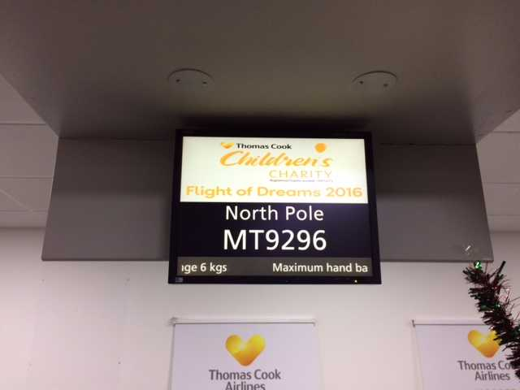
Our positive relationship with Clyde 1 Cash for Kids offered the opportunity for children and young people to have a Flight of Dreams experience in December 2016. The children experienced going through customs, boarding the aeroplane, an hour flying to the ‘North Pole’ and a visit from Santa while in the air. They each had lunch, a gift from Santa when they visited his grotto on returning to the airport and finally meeting real live reindeers before home. One child said “is this how it really feels like to go on a holiday?” Another said that it was “the bestest thing ever in my whole entire life”. Thank you to Clyde 1 Cash for Kids and all the children who participated

REFUGE
This year at refuge has, in some ways, been the same as always-not enough flats – with only 10 out of 61 requests accepted . As a result women and children cannot get the benefit of safe and supported accommodation. But as the East end of Glasgow changes, so does demand for refuge.
The well documented reduction in the number of homes in the East end acts as a double squeeze with families staying in refuge longer.
We have many more families who are new to Scotland and sometimes their immigration status is uncertain and not indefinite, which brings addition strain and uncertainty to the family. There are also cross border issues as the legal system in Scotland and England are different. In our experience women find it very expensive to get legal representation at family court hearings down south, again acting as a barrier for women to make the break with their former partners and to keep their children safe.
Budget cuts elsewhere mean that our funders don’t have the ability to increase payments and a stand still award is viewed at this time as a success. Over recent years we have been actively involved in national campaigns to have Women’s Aid refuges recognised and protected from cuts in housing benefit which would decimate our service.
We have received ongoing support from local political representatives, which have been invaluable, but we fully expect further attempts to undermine the ability of Women’s Aid to continue our work.
Glasgow East Women’s Aid may be nearly 25 years old but sadly the need for our service and threats to our existence have not faded away.

STATISTICS
2000-2002 2016/2017

No of contacts: 1355 No of Contacts: 2931

Source of referrals: Source of referrals:

Self: 1116 Self 1564
Friends or Relatives: 44 Friends/Relatives 85
Other WA Groups: 54 Other WA Groups 69
Other Vol. Organisations: 44 Other Vol Agencies 130
Social Work Department: 15 Social Work Department 401
Housing: 17 Housing 39
Police: 15 Police 114
Medical Agencies: 24 Medical Agencies 184
Others: 26 Others (Lawyers, Clergy) 28
School 9
Unknown 45
MARAC/ASSIST 263

COMPLIMENTARY THERAPISTS
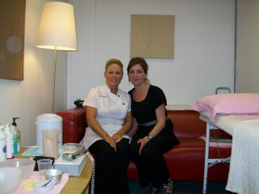
Geraldine and Claire are a valuable asset to GEWA. They offer massages, facials, reflexology and waxing. Woman value the time that they have to themselves; where they have the opportunity to relax and enjoy the benefits. A session with Clare or Geraldine helps to promote relaxation and develop a greater sense of worth.

UPW
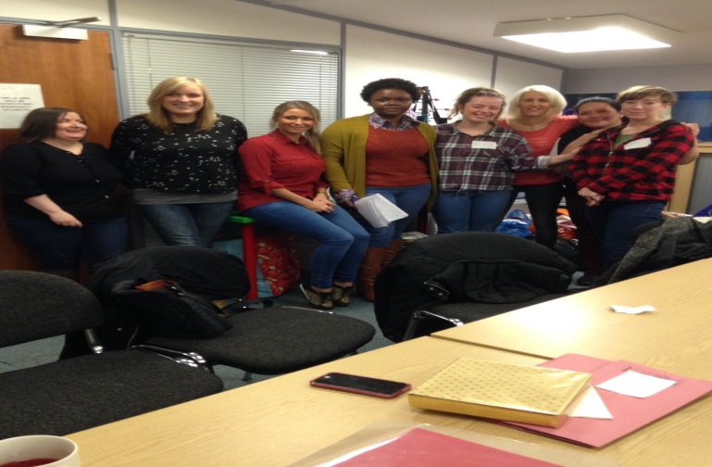
We have an amazing team of women, who come to GEWA to volunteer one morning or one afternoon every week. They first of all attend a 10 week training programme, and then we have a buddy system for as many weeks as the volunteers feel they need before becoming independent. It is a great programme and having them give us admin support, advocating on behalf of the families who attend crisis drop in and any other support that women need, is something we would not like to be without. This often results in our volunteers moving on to full time paid employment.

DA FAMILY FINANCIAL SUPPORT SERVICE

Clare is kept busy with an ever increasing demand for this service, her work is focused on both providing ongoing emotional long-term support and delivering shorter term financial interventions (however these can also be very lengthy!!). This can include income maximisation checks, criminal injury claims, local grant applications, PIP applications, uptake of unclaimed benefits and support through the appeal process. This year Clare has helped women and their families to claim over £70,000 that they were entitled to….amazing work Clare!!!!!
This year the DAFFSS worker co-facilitated an integrated groupwork programme that used artwork to explore elements of financial abuse, welfare reform, austerity measures and gender inequality. The art work produced in this was also displayed at the conference and presented by 2 women from the group to our delegates.
Clare was involved in doing an interview with the Criminal Injuries Compensation Authority in Glasgow due to a rise in the number of applications from our client group, enabling barriers to women’s claiming CIC to be addressed. Clare has also regularly linked in with other third sector and statutory organisations to ensure that the relationship between domestic abuse, financial hardship and poverty remain firmly on the local and national agenda.
WOMEN
We are grateful for the continued funding and support from Glasgow City Council through their Integrated Grants Fund. This Grant enables Janice Hannaway, Anne Smith, Annette Keenan and Louise Doyle to deliver the invaluable service to women who have experienced Domestic Abuse.
Throughout the reporting period we again continued to offer crisis intervention where practical support was offered to assist women with the difficult transition of fleeing domestic abuse.. Further services included rehousing, advocacy, 1:1 therapeutic counselling, group work, legal advice, support for women to provide statements to the police, court support, benefit advice, representation at child protection case conferences and the Children’s Hearing System.
Furthermore we have supported women to remain free from abuse and ultimatley live safely within their homes and communities. We have reduced the risk of further harm to women and increased knowledge and understanding of domestic abuse with external agencies.
Through our proactive interventions and ongoing commitment to our service users we contributed to increasing confidence and resilience, maximisation of income, reduction in povery, increased empolyability/ educational attainment for women.
Through our ongoing partnership work we continue to raise awareness of the issues and effects of gender based violence throughout the local and wider community and at a statutory and voluntary level.Thus empowering women children and young people and all members of society to confidently report gender based violence crime. Successful work with our partner agencies has created robust avenues to provide Gewa services on an outreach basis. This has ensured that marginalised groups continued to receive an inclusive service.
Quarriers Family Resource Centre continued to be a valuable partner agency throughout 2016/2017. Janice Hannaway facilitated two successful wellbeing groups to women surivivors of abuse. The groups empowered women to attain knowledge relating to the prevalence and effects of domestic abuse. Furthermore the groups provided a safe space where issues were explored in a therapeutic context. Janice’s interventions and reflective practce allowed women to explore and addresss the traumatic effets of multi faceted abuse. Therefore womens recovery commenced as they were emotionally, physically and psychologically safe from the traumatic effects of abuse.
Anne Smith attended a conference at Stirling University facilitated by The Scottish Drugs Forum to engage agencies to address the needs of older drug users. Through Annes participation in workshops she provided an insight into the links between domestic abuse and substance misuse. Anne contributed to the report compiled by the SDF to ensure the ongoing wellbeing and the reduction of complex needs in individuals who continued to use substances as a coping strategy on a long term basis .
An ongoing challenge we faced throughout 2016/2017 was the lack of suitable social housing for women and their families at a time of crisis when fleeing domestic abuse. We have also witnessed the negative effect the government benefit reviews and sanctions have had on poverty and deprivation where financial abuse already existed.
We have continued too support an all inclusive service by breaking down barriers, such as working with women in addiction , PTSD/mental health, women from BME and ethnic communities , lesbian, bisexual, transgender and women with disability.
Our ultimate aim is the eradication of all forms of gender based violence.

CONFERENCE
We hosted a conference in March this year in order to raise awareness of the different forms of domestic abuse to include coercive control and the impact of this on women, children and young people. 185 delegates attended the event and there was a mix of professionals and women from the community. Our guest speakers were from Stirling University, Procurator Fiscals Office, Scottish Women’s Aid and children and young people from GEWA. The variety of speakers offered information on how adverse childhood experiences have a detrimental impact on adult health and wellbeing (ACE) and the importance of assessing the risk and how we respond to the myriad of factors identified. Anne Marie Hicks (Procurator Fiscal) gave a presentation on the new Domestic Abuse (Scotland) Bill which introduces legislation to criminalise psychological abuse. Marsha Scott from SWA presented on domestic abuse and co-ercive control which offered important information on the impact for both women and children and young people. The afternoon session focused on children and young people’s experiences of domestic abuse and how support from GEWA has assisted them to move on with their lives. This involved a young girl who has used our children’s service who offered an overview about the children & young people’s Art Group and Photo Story and a young person who previously used our service and is achieving well in his life.

FEEDBACK FROM ATTENDEES
"Amazing resilience and humour from the young person in the afternoon"
“I have a greater awareness of how to recognise psychological abuse and how to provide options/help”
"Would like to hear from young people at future conferences"
"The children's experiences were really thought provoking"
“I am more aware of the impact of this type of abuse and will use it in my social work practice”
"Children's views on domestic abuse were particularly useful and inspiring"
"Hearing the children's points of view made this topic very real"

THANKS TO
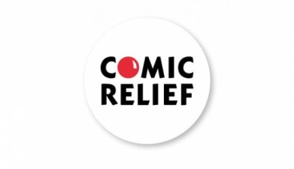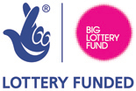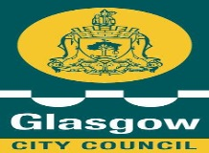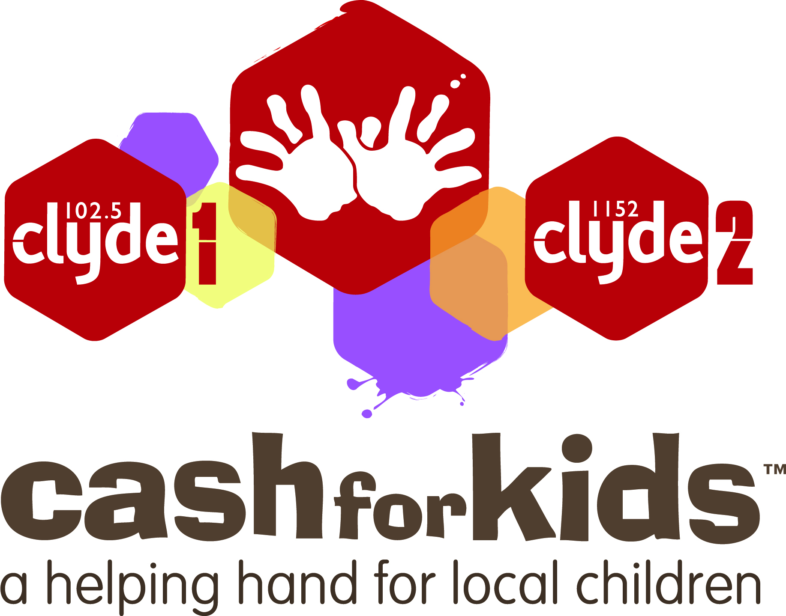

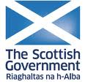

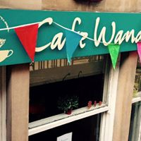

ALSO - Father Ness (St Benededict’s Chapel) Rev. Cuthbertson, (Mure Memorial Church)
Salvation Army, Easterhouse (Tom & Pamela), St Claire’s Church, Pat Smith, La Rocha Rumba, Penumbra, McVities, Atlas, Scott Pierce Flynn, Eric Dominy, St Mungo’s Academy,

