ANNUAL REPORT 2020-2021

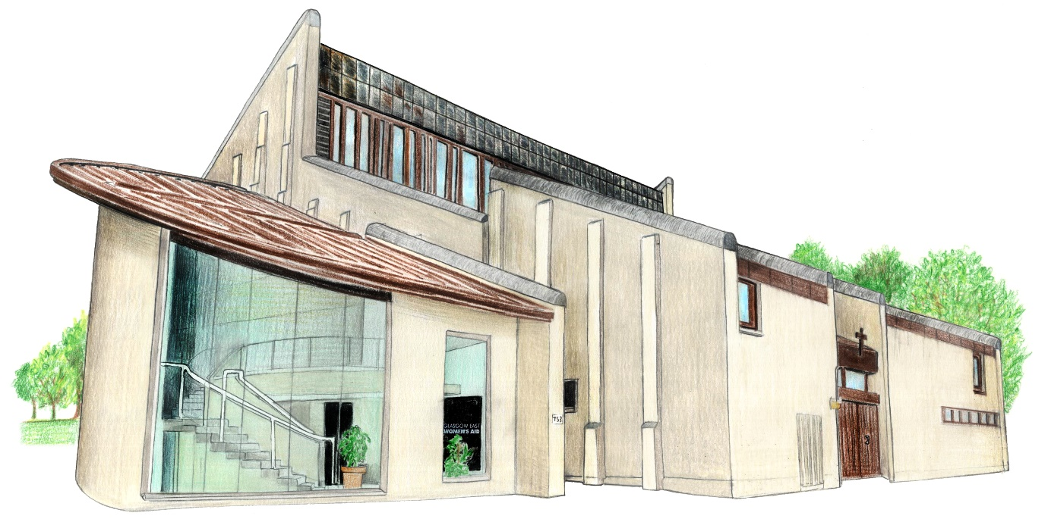

753 Westerhouse Road, Easterhouse, Glasgow G34 9PB
Tel: 0141 781 0230, Fax 0141 771 4711
Email: info@gewa.org.uk Web: www.gewa.org.uk

WOMEN’S SERVICE

“The number of charges for domestic abuse crimes in Scotland has risen to its highest level in four years, according to prosecutors. The Crown Office and Procurator Fiscal Service (COPFS) also said the proportion of cases resulting in court proceedings was at a six-year high.”

The above statement highlights the stark reality of continued rise of Domestic Abuse in Scotland. As we continue to navigate our way through a global pandemic and ever-changing restrictions to our lives, Women also continue to strive to ensure their safety and protection of their children from perpetrators of abuse.

GEWA’s Support and Advocacy Service has continued to provide vital support to Women experiencing Domestic Abuse. We continue to provide emotional and practical support both on a planned basis and through our Crisis drop-in. We provide support to Women to ensure their voices can be heard through different processes and to advocate on their behalf when working with other professionals.

Our last year at GEWA has continued to be a busy despite the pandemic; our referrals increased significantly with our peak being September 2020. This continues to highlight the ever-increasing need for VAWG services and how important their role is within the community. Our frontline work has coincided with campaigning against recent funding cuts at North Lanarkshire Women’s Aid. We continue to be strongly opposed to funding cuts for VAWG services and will continue to use our voice at GEWA to support our sister groups affected by this.

“The additional pressures placed on domestic abuse services and the survivors we support by the pandemic are well known and have been highlighted by SWA and Scottish government, amongst others”

Achievements

In November 2020, we welcomed our new Women’s Worker, Hannah Inglis to our team. Hannah was a valuable member of our Unpaid Worker Team and to have her now on board as a member of the staff team is testament to the successful UPW programme we run at GEWA and the hard work and commitment shown by the Women. Long may this continue.

A recent service evaluation was conducted by our Women’s Worker, Cara Wilson. We received extremely positive feedback from our service users. A report of findings from the service user evaluation is currently being drafted.

We continue to connect and engage with our women and the wider community through our Social Media platforms and want to thank Hannah Inglis and Nikki Chung for the hard work and effort they put into running our platforms. We have seen an increase in women reaching out by this method of communication and we feel this is breaking down barriers to accessing support.

We now have three members of the staff team trained in delivering the Own My Life programme. The course provides a 12-week programme to empower Women to take back control of their own lives. All three members of staff gave rave reviews of this training, and we hope to deliver this when restrictions ease.
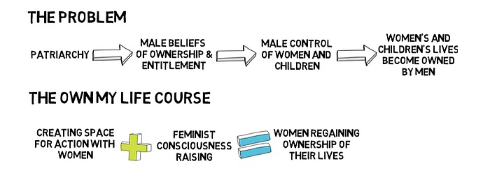

Our Women’s Team have continued to source training and development to improve on their practice throughout the year and we are grateful to our training partners out there who have adapted their service delivery to facilitate this. We look forward to getting back to face to face training and networking with other professionals.
Events
Despite the difficulties of the pandemic restrictions, we have still been able to run several successful online events and organise special treats for our Women, Children and YP.
In December 2020 we were able to run a successful Christmas Appeal which saw us receive gift and monetary donations – this meant we were able to provide Christmas gifts for our Women and their families. Christmas is a stressful time for a lot of people but especially so for Women who are experiencing Domestic Abuse. With financial abuse being prevalent in most Domestic Abuse cases, our appeal was able to go a small way of alleviating some of the pressure on our women.
We were supported by several organisations during our Christmas appeal, and we want to thank them again for their kindness and generosity:
- Glasgow’s Spirit of Christmas
- Anas Sarwar Foundation
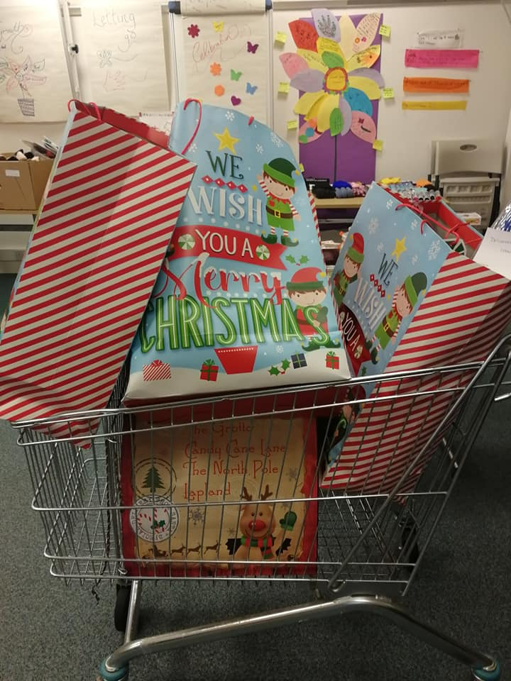
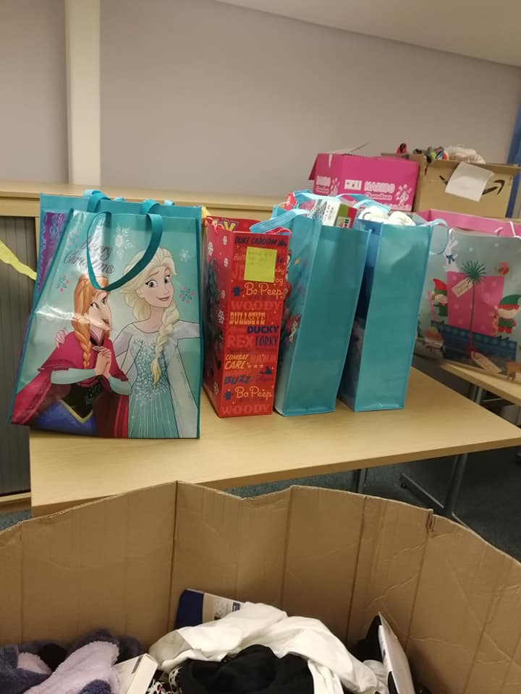
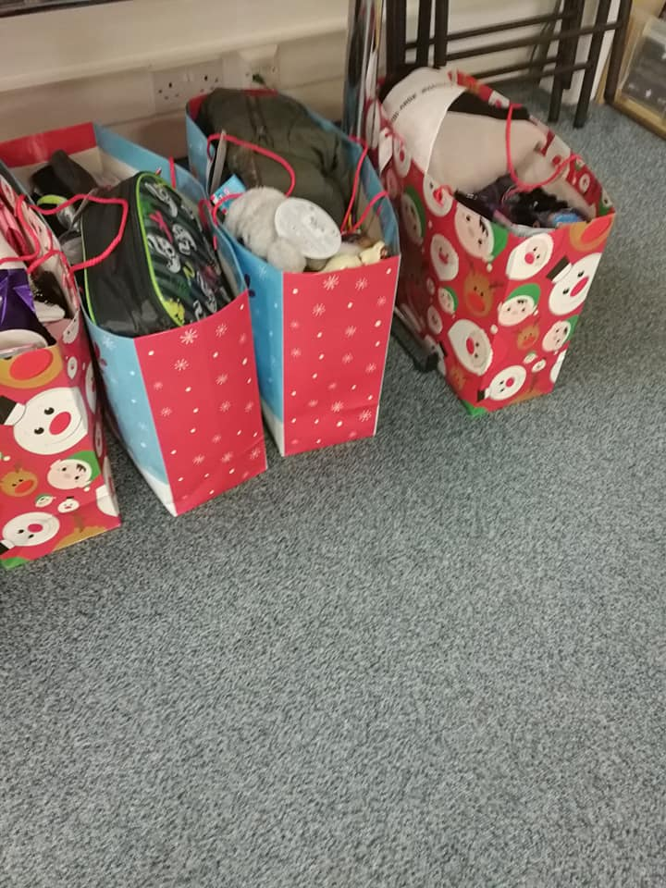
- Social Bite – who provided Christmas meals for our families.

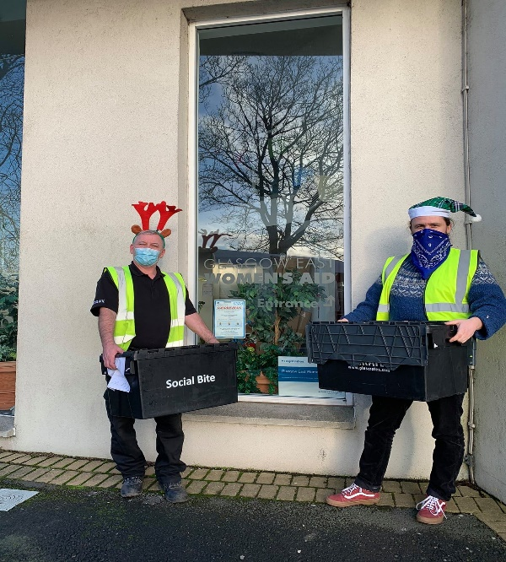

During our Christmas appeal our JustGiving campaign raised £1325 which was an amazing amount from the public. We also received separate donations from members of the public or local organisations.
We continue to receive ongoing support from organisations listed below. Without this support we would not be able to stock our Food Shelves and provide the emergency supplies that our Women often need. We are truly thankful for their support:
- Celtic FC
- Kimberley and the Team at Teleperformance
- Poundland – The Fort
- Morrisons – Auchinlea
- Morrisons – Baillieston

We also provided vouchers for Mother’s Day and Easter Eggs this year to ensure our Women and their families were able to have a nice treat on their special days.

International Women’s Day: Self-Care Workshop
As a Feminist organisation, we strive to appreciate women every day. When it came to organising our annual International Women’s Day celebration, we as an organisation chose to hone in on the resilience shown by our service users, as well as our staff team, throughout a tumultuous time of continuous lockdowns.

The start of lockdown put significant pressure on women to not only adapt to the ‘new normal’, but to prioritise their needs in regards to self-care. For women living with their experiences of domestic abuse, this is often not possible due to caring responsibilities, trauma, and financial constraints:
“While (perhaps) well-intended, this pressure to ‘use our extra time productively’ creates another layer of unrealistic expectations around how women should be navigating this unprecedented period.”
GEWA recognised our ethos as a service to empower women, and to work towards providing a safe space for reflection, growth and connection. Our online workshop thus consisted of discussions around self-care, healthy vs unhealthy habits, as well as craft elements to express feelings and reflections through
art. Workers Hannah and Nikki devised a full programme of events, as well as sending out self-care packs to all attendees.
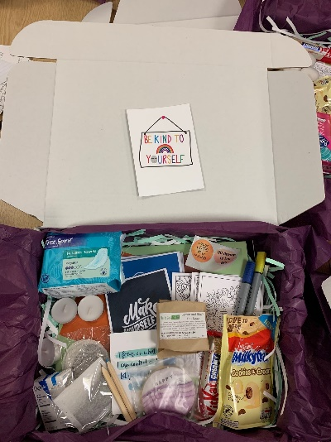
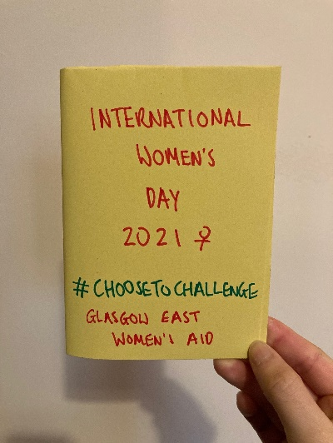
Through opening our discussion to all attendees, power-barriers and anxieties were broken down. This has resulted in confidence in connecting with others, especially online, with a service user stating:
“This workshop really brought me out of my shell; I was nervous to engage online but the layout of the workshop really helped. I’d love to be involved in more events and groupwork in the future.”

The success of this online event has provided a great baseline for our service adapting to online platforms, if required, in the future.
Challenges
The last year has not been without its challenges; there continues to be ongoing difficulties with the link between stalking and harassment and criminality. There appears to be difficulties in recognising the impact of living in a state of fear and alarm between survivors and Police Scotland. Women are being repeatedly told when experiencing stalking or harassment that no criminality has taken place despite increase in frequency and severity of the covert abuse. One of our clients was told “just close all your blinds, then you won’t see him” The court case for this woman has been postponed three times, therefore she would have been living without light for 18 months should she have taken this advice from the police. Our women deserve better.
There is a disconnect in how Domestic Abuse cases are being approached by Police Scotland and it is felt there is significantly more work and training that needs to be undertaken. A formal complaint has been made by a member of the staff team to Police Scotland after inappropriate language was used by an officer while taking a statement from a Woman we support. It was felt this was necessary given the comment made and the nature of the situation. We hope this can improve practice going forward.

CHILDREN’S SERVICE

Who could have prepared for a year like 2020 with COVID and impact that it had globally? The CYP service responded to this by offering a blended approach to service delivery with face to face being the preferred choice and providing WhatsApp, zoom calls, Facetime and Text as alternatives, to meet Government guidelines.
We were lucky to receive funding to ensure that we could provide our CYP with the necessary IT to be able to continue support. While we were able to offer this with some success, we acknowledge that it brought its own difficulties such

as risk assessment, privacy and the CYP being comfortable to speak in their own homes.
We offered online groups such as Healthy Relationships, the Summer Group with the theme being transition, change and growth which the CYP really enjoyed. We also offered a Scrapbook group in partnership with Young Women Scotland, where personal journals were made using arts and crafts.

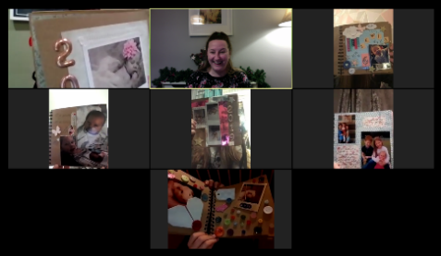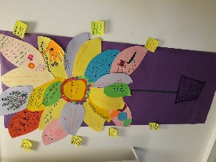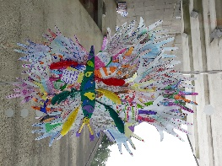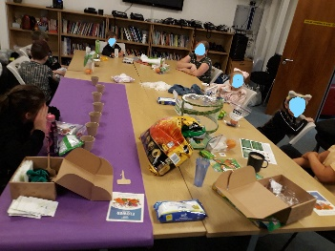

PARTIES
Continuing the theme of emotional wellbeing, the Team Leader had been given feedback from other service users that not being able to see friend or go out was really impacting on their mood and behaviour. Team Leader then suggested that we could still celebrate themes such as Halloween, Bonfire Night and Christmas by offering visual parties. They attended very well, and feedback was very positive from CYP, parents and carers, and referrers such as social workers who feedback that the families had raved about them.

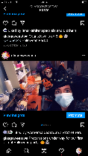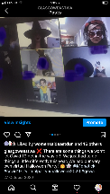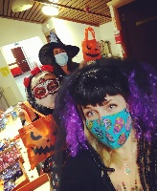

SUCCESS 2 SOCIAL MEDIA
Facebook, Twitter and Instagram have proved to be effective tools in supporting women, CYP experiencing domestic abuse. These mediums of communication are valuable tools in highlighting ongoing and current issues. We

continue to upload advice for CYP and parents on the COVID-19 virus, tools for learning, mindfulness, yoga, signposting, news, raising awareness of the full impact of domestic abuse, activities and events, support networks etc. We have had positive feedback from partner agencies and service users to include;
Social service worker - I didn’t realise the scope of the fantastic work carried out by Glasgow East Women’s Aid. I have found myself using their Facebook page as my go to for any info I need, it has great links as well.
Mother – GEWA’s social media has been a blessing for me during this hell. It has so much to help me and activities for the weans thank you GEWA angels.
Girl 14 – I love being part of the TL group. It has really helped me understand why I feel the way I do and it’s so important to get the message out there. I feel part of something special #gewaissic.
Service Demand
Unfortunately, we have seen a significant rise in our waiting list with referrals at an all- time high and we are working hard to address this.

MADW SERVICE
GEWA welcomed Nikki Chung (previously a Women’s Worker), into the Full-Time position as the Multi-Agency Outreach and Development Worker (MADW) in March 2021. This work involves engaging with external organisations to build awareness around gender-based violence. Similar to the rest of our services, the MADW adapted to working from home. Pre-COVID, the MADW delivered our 12-week Unpaid Workers Course in-person, information sessions to external agencies were given at our office, we held physical information and drop-in stalls at local community centres and undertook a lot of outreach work through speaking to different communities and professionals.

We were fortunate enough to be able to move our training online. Since August 2020, we have delivered 6 trainings to external organisations, reaching 39 Health students, Social Work students alongside other professionals such as sexual health practitioners, drugs and alcohol workers, mental health professionals, housing officers and other third sector organisations. The sessions informed

practitioners about where gender-based violence stems from (gender inequality), how to recognise the different forms of abuse and how to support women in
abusive relationships. This includes explaining how to make a referral to GEWA, safety planning and providing useful helplines for further support. Agencies are more informed about the services we offer and will subsequently make referrals to us. We aim to do this online (until restrictions ease) on a monthly basis to raise awareness of gender-based violence.

Our 12-week Unpaid Workers Course is a course for women interested in learning more about domestic abuse and our services and upon completion, they may have the opportunity volunteer with us. The content was updated to include discussions around the root cause and consequence of violence against women – gender inequality. The course ran online in January to March 2021 due to COVID-19 restrictions. Eleven women from a variety of backgrounds attended the course. Discussions focused on the different examples of gender inequality and gender stereotyping. We also felt that it was important to raise awareness of harmful media reporting of violence against women and why we should challenge and be critical of victim blaming language and avoid sympathising with abusers. We invited external organisations such as Shakti Women’s Aid and People First (Scotland) to deliver training to attendees. This aimed to highlight that women’s experiences of gender-based violence are not monolithic. That is, there are additional barriers women face due to their race, ethnicity, disability, sexuality, including other protected characteristics which combine and results in different forms of inequality. We look forward to running the course again in Autumn 2021.

Multi-Agency Risk Assessment Conference (MARAC)

MARACs are being held online on a monthly basis. We work with multiple agencies in the North East area of Glasgow to identify the risks service users may be exposed to and work together to form an action plan to ensure women and girls’ safety and well-being needs are being met. This includes safety planning.

Events

For International Women’s Day 2021, we hosted two separate ‘Crafternoon’ sessions – one with staff and service users and one for our Unpaid Workers

attendees and existing volunteers. We focused on gratitude and self-care. We packed craft boxes, which were sent to 75 people. It included positive
affirmation cards, paper, origami paper, coloured pencils and pens, soap, sweet treats, tea lights, teabags and menstrual products.

After a blur of a year, we thought it was important to reflect back on 2020. We reminded ourselves of what we achieved, no matter how big or small, what we are thankful for and how we practice self-care. For some, it was making it through home-schooling alongside studying and other caring responsibilities, for others it prioritising ourselves or finding a distraction and taking up a new hobby like knitting. We celebrated this and made them into zines for attendees to keep as a memory of their journey. We rounded off the event with making an origami flower – a symbol of growth and change that we have all experienced in the past year.

There will be an online event, COVID-19 and Domestic Abuse: A Year in Reflection and What’s Next, in June. We have invited three speakers to present at the event – Dr Kristina Saunders from The University of Glasgow, Fiona McMullen from ASSIST and Anila Mirza from Shakti Women’s Aid. We are looking forward to hearing from them and from our attendees.

Challenges

We have been unable to do monthly drop-ins within community venues or deliver capacity and capability building workshops to women and girls. However, we are adapting to the situation and thinking of innovative ways to approach this. We are looking to contact different centres and ask if they would like to set up online drop-in sessions with us so we can reach women and girls to increase women’s knowledge and understanding of gendered analysis of abuse.
REFUGE
To say that 2020/21 has been one like no other is no exaggeration. Refuge is a service that is routed in supporting women and children at our refuge where there is an office children’s room counselling room as well as refuge flats. It’s a small community where there is a mixture of formal and informal contacts. Not so in the past year.

When the tightest of lockdown regulations were in place and staff were not able to travel, we quickly switched into telephone contacts and took advantage of several schemes that were set-up to provide support.
With customary GEWA can do attitude we contacted companies, local and national as well as scouring the Scottish government and Glasgow City websites to see how we could tap into resources for our families.
Local shops such as Poundland and Morrisons donated food and toiletries, Kids Out helped with toys and arts and crafts. The Scottish gov gave us vouchers to access Kindles and our landlord Wellhouse gave tablets. WE also made sure that families, who were eligible, had the Glasgow City Farmfoods card for school meals.
WE also successfully applied to Foundation Scotland, and we were able to give families vouchers for local supermarkets and for B and Q to help them when they moved into their permanent homes and for taxi travel when public transport was limited.
It was a very traumatic year for women trapped in abusive relationships and we signed up for and used the Rail to Refuge scheme which allowed families from anywhere in the UK to get free rail travel to come to our refuge.
The year was also a stressful one for staff and we were all provided with the appropriate PPE and given guidance on home and office working. We took part in keep fit zoom sessions and took up the offer from the Glasgow Social HealthCare Partnership and all refuge staff received their two jags to allow us to return to face to face work when local conditions allowed.
As we begin to return to more regular refuge-based activities and events we can say that although we hope never to have another year like it that GEWA and the refuge staff rose to the challenge and took every effort to provide as good a service as possible given the very difficult circumstances.
We would like to with our two long standing colleagues Tricia and Agnes who retired during this year, and we wish them many happy and healthy years to come.

FAMILY DEVELOPMENT SERVICE
The Family Development Service has been running at GEWA for over five years. Current funding for the programme is provided by The Henry Smith project. Our Family Development worker Louise is committed to delivering the best possible support to families who have been affected by domestic abuse.

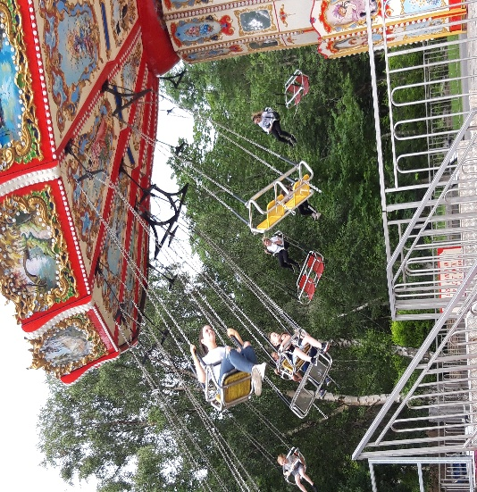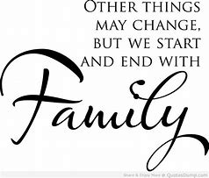

Family dynamics change significantly after living in an abusive situation, resulting in the breakdown of attachment bonds which has a detrimental effect on relationships, with this comes a lack of structure, routine and boundaries are often lost.
Providing a holistic, needs-led support service to families experiencing or who have experienced domestic abuse, enables resolving many issues of emotional trauma, stress and loss. This can involve practical support, advocacy support throughout court and child protection procedures and education around DA and its impact on each member of the family unit
Designing and implementing individual care plans according to the needs of each family is an integral part of the service as is providing outreach support and activities, in addition to our office-based provision.

The service strives to ensure that each family will leave feeling a sense of safety, wellbeing and increased confidence allowing them to move on with their

lives in a positive direction. The family service is an essential part of the recovery from domestic abuse for women and their children.
Throughout the COVID 19 crisis the Family Development Service worked hard to ensure no family did without, supported virtually and practically providing food and activities and clubs when restrictions allowed. Continuing support throughout this period has ensured the mental health of the families has been supported and cared for.

SURVIVOR, TRAUMA, ABUSE, ADDICTIONS RECOVERY WORKER
This year GEWA welcomed Heather Carrigan to this role, she continued the role after Donna had left for pastures new.
The STAAR service continues to address the complex needs of women experiencing co-occurring domestic abuse and substance misuse issues. Women in this group (Drug, Alcohol & Domestic Violence) are underrepresented and often excluded from services, the STAAR service is implementing change by offering an integrated approach to recovery.
Referrals continue to rise with the service being more established.

Our STAAR worker Heather attends regular meetings within the North East Alcohol & Drug Partnership, tackling alcohol and drug issues through partnership working. An overview of the STAAR service has been presented and has enabled more woman to be supported, as external agencies are aware of the service and how to refer.
Digital devices were sourced from Connecting Scotland in response to COVID -19. It was especially important for women to link in with support systems such as online Recovery Meetings during this time.
The service continues to focus on raising awareness of Domestic Abuse and reducing the impact of addiction. New areas of support have been identified within the service such as problem gambling and supporting the over 50’s age group in addiction recovery.

Women are empowered to be involved in their own individualised support plans. Substance misuse is treated alongside a woman’s overall circumstances.
Challenges – delays in domestic abuse court cases due to the pandemic has been extremely difficult.

COMPLIMENTARY THERAPIES- REFUGE-LOUISE MCCONVILLE
In the beginning both myself and the women found it a little hard to adapt due to my services having been face to face and hands on. Some of the women in refuge preferred just a phone call so I could only hear them but not see them, which made it harder to gauge how they were really feeling.

We would work together using relaxation techniques and some stress management tools, I would also record at meditation and send it to them.

The women that I could do a zoom call with I would take them through a guided meditation and we also chatted about how they were feeling and we talked about ways to cope with feelings of what was going on also some tools and techniques to help the children

They would also receive a copy of the meditation through WhatsApp
I feel and know by what the women have said that the zoom calls and being able to speak to someone face to face so to speak helped them.

They also said that being able to understand how their mind was working and also understanding their emotions helped them to get through this but also knowing that they were part of a support group made a big difference also to how they were feeling

COMPLIMENTARY THERAPIES – OFFICE- CLAIRE HANNAWAY

.
I provide various complementary therapies to help relieve symptoms of long-term health conditions, ease physical and emotional symptoms to regain the balance between the body and mind, this enables clients to take more control

of their decisions and make positive life choices leading to improved overall wellbeing.

When the Covid-19 Pandemic took hold in April ’20 service users had to adapt from face to face therapies to online or telephone sessions. Initially a few clients did feel the loss of face to face connection but soon stated they felt
more familiar and relaxed in their home online environment. Creating a defined time and space for therapy sessions helped clients to be calm, relaxed and free from distractions whilst ensuring confidentiality and safety.

The Covid crisis has triggered feelings of isolation and depression, the social isolation leads to loneliness which can have detrimental effects on physical and mental wellbeing. The chronic stress of living through the uncertainty of this pandemic has led to a host of physical and emotional symptoms for many people. Staying connected and engaging through online and telephone sessions has been a lifeline for clients and reassures them that “we are all in this together".

During this pandemic I have supported and connected with clients using the following relaxation techniques;

Deep Breathing - This stimulates the vagus nerve, which runs from the head down the neck, through the chest and to the colon. This activates your relaxation response, reducing your heart rate, Blood Pressure, and lowering stress levels.

Progressive Muscle Relaxation – This is a two-step process in which you tense and relax different muscle groups in the body which gives a familiarity with what tension and relaxation feels like in different parts of your body. This helps you react to the first signs of muscular tension that accompanies stress. As your body relaxes, so will your mind.

Body Scan Meditation – This focuses your attention on various parts of your body but instead of tensing and relaxing muscles you focus on the way each part of your body feels while breathing deeply and slowly throughout.

Mindfulness Meditation – This switches your focus to what’s happening right now rather than worrying about the future or dwelling on the past allowing
you to be fully engaged in the present moment strengthening a new mental habit and encourages you to release internal thoughts, worries and regrets.

Distant Reiki - Assists in the body’s natural healing processes, induces deep relaxation, helps clients cope with difficulties, relieves emotional stress and improves overall wellbeing.

FINANCE

As with everyone else, 2020/2021 proved to be a year like no other for every individual and every organisation. Overall, we were very fortunate with funding in 2020/21. For that, staff and service users are truly grateful. For each pound generated it makes a difference to someone’s life.

We must start the year with the COVID epidemic. This was a game changer for all of us and we have had to adapt alongside everyone else with the challenges and trials that brought us.

From day one we were incredibly lucky to receive funding in all areas to provide additional support to people living with Domestic Abuse and the effects thereof.
We were contacted by funders that we currently receive grants from and also from other areas to offer whatever support they could to allow us to carry on and get the direct support to where it mattered.

Amid all this turmoil and uncertainty here was all this kindness………

It made a very difficult time more bearable. Awards were issued without the need for huge application forms and constant monitoring. It was just get it to the people that need it and report on it later. For all your support we will always be eternally grateful.

I would like to name some of our COVID emergency funders that stepped forward. They are in no particular order – STV Appeal, Foundation Scotland, Groundwork UK/Tesco, Neighbourly Community fund, Scotwest Credit Union,

Co-op Foundation, Children in Need, National Lottery/Awards for All, Comic Relief – Big Night In, Scottish Women’s Aid in partnership with Comic Relief and the Scottish Government.

We will never be able to thank you enough for making such a difference to so many people’s lives, especially when It mattered.

As we started the year there were many uncertainties with major funders.
Would we be awarded funding from the new GCC fund – Glasgow Communities Fund? If so, how much? What would this mean for our services?
Thankfully, funding was approved, and we received enough to continue to provide support for women. This funding is a rarity in that it is a 3-year fund with approval for the funding to continue until 30.9.23. However, there is to be a cut in year 2 and 3 that we will need to try and replace to keep services at the current level.

In other GCC funding – Grants to Vol. Orgs. and in Supporting People we received the same amount as previous years, this is a huge relief that we did not have to sustain any cuts in these areas.

As we end the year there are more uncertainties with funding from another of our major sources. Namely the Scottish Government, we are currently funded for our Multi Agency Worker and all our Children’s Services. As this fund is due to end on 30.9.21 we have applied to replace this from the new fund – Delivering Equally Safe, this is a progressive fund created by the Government and has been a rigorous application process which was submitted at the end of May, we await the decision. Keep everything crossed for us please!!

We continued to receive funding from The Robertson Trust to provide our financial advice service which increases in demand year on year. Clare is currently seeking match funding from other sources.

We have agreed an extension on our funding from Henry Smith Charity to allow the Family Support service to continue for a few extra months, during this time we will be actively seeking alternative funding as with all other areas of the service this is in great demand.

Our funding from Comic Relief is due to end in 2021. Comic Relief are always very active in their support for Women’s Aid and the work we do and for that we are very grateful. Our new worker has secured funding for when this fund ends.

We have also received donations from many other sources (not COVID related)
They include Celtic F.C., Arnold Clark, Green Watch Easterhouse Fire service, Salesian Sisters St. Benedicts, UNITE, St. Brides S.V.D.P., Muir Memorial Church, Kelvin College, Easterhouse Street Party, Just Giving donations from many individuals. We also received donations from people whom I will not name as I do not know if they wish to be recognised. They are C.D., A.E.M., A.M., K.H.

To all our wonderful funders big and small. It has been an absolute pleasure to work in partnership with each and every one of you.
As a staff member of a third sector organisation, we do not have the security that other workers enjoy. We are constantly striving to secure funding which allows us to keep our jobs. Many years ago, this was something that happened for the last 3 months before the funding year ended. However, as the world has changed so has the demand for funding. This is now a year-round event where workers are constantly striving to do their job and secure appropriate funding to keep that service going. Unfortunately, this past year has shown us that Domestic Abuse, is very much still on the increase and the demand for the specialised services we provide is ever present. In order to do this, we need the help and support from all of our funders. Quite simply without you we do not exist.

Women helping women helping women

“All women and girls have the fundamental right to live free of violence. This right is enshrined in international human rights and humanitarian law, and it lies at the heart of my UNITE to End

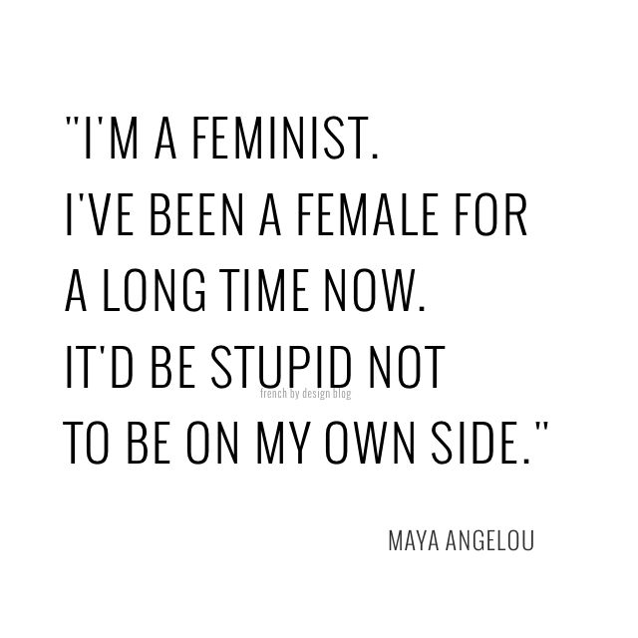

HERE’S TO STRONG WOMEN

MAY WE KNOW THEM
MAY WE BE THEM
MAY WE RAISE THEM

https://www.bbc.co.uk/news/uk-scotland-54071027
https://womensaid.scot/letter-to-nlc-12th-march-2021/
https://www.ownmylifecourse.org/theory-of-change
Reclaiming Our Self-Care as a Feminist Act (cofemsocialchange.org)
Service User, GEWA

