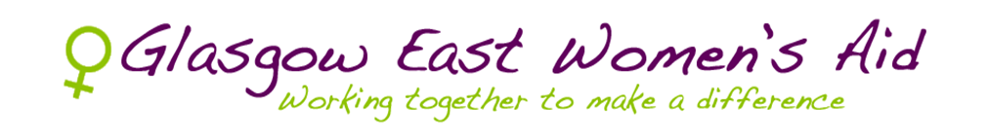

ANNUAL REPORT 2019-2020

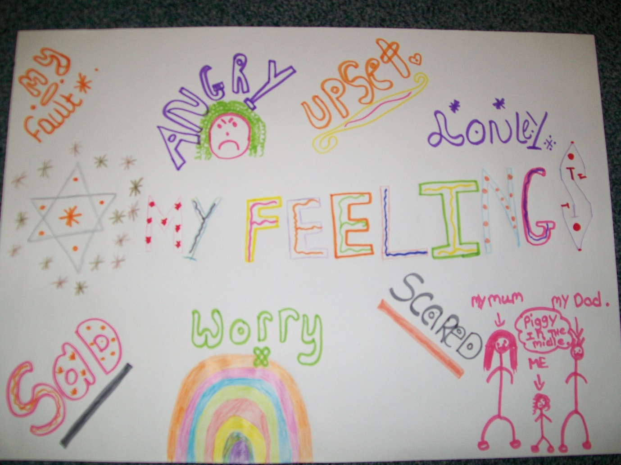

753 Westerhouse Road, Easterhouse, Glasgow G34 9PB
Tel: 0141 781 0230, Fax 0141 771 4711
Email: info@gewa.org.uk Web: www.gewa.org.uk

WOMEN’S SERVICE

The statistics released by the Scottish Government in February 2020 revealed that the police recorded 60,641 incidents of domestic abuse in 2018-19, an increase of 2% compared to the previous year. Amid the Coronavirus outbreak, the National Domestic Abuse helpline has seen a 25% increase in calls and people seeking advice. These figures show that domestic abuse is not declining and that there is much action needed to protect women and their children from perpetrators. Glasgow City Council’s Integrated Grants Fund has enabled Glasgow East Women’s Aid (GEWA) to deliver life-saving services to implement this.
GEWA has had a busy year. We welcomed three new Women’s Workers – Laura Vernal, Cara Wilson and Nikki Chung. Their responsibilities include providing emotional support, referring women to the Multi-Agency Risk Assessment Conference, liaising with other professionals such as Social Work and signposting women to other services such as mental health. Vital to protecting women and their children is safety planning. This plan is discussed with each woman to increase her and her children’s safety.
We had another successful Masters in Social Work student placement. This was endorsed by an incredibly positive email from the university. These placements are imperative for students to develop their frontline experience. Additionally, it provides them with an insight into how women are affected by domestic abuse and gives them an understanding into why a multi-agency approach with other professionals is crucial.
The continued funding issue was ever present and GEWA was incredibly grateful for the support of representatives Maureen Burke (Labour) and Mandy Morgan (SNP) who gave of their time to meet with a representation of GEWA service users.
Women who have experienced or are experiencing domestic abuse are often undermined by the perpetrator. Hence, our service users have noted that GEWA is a safe space for them to talk about their emotions. Exploring how service users are feeling, provides us with an understanding of how women are affected by domestic abuse. This includes feeling anxious, frightened, hopelessness and trapped. Women’s Workers work with service users to discuss these feelings and to validate their experiences and thoughts. GEWA has been described by women as invaluable to them and that they could “stay at GEWA 24 hours a day as they feel safe, listened to, understood” and taken seriously.

Achievements

Social media is a powerful tool for raising awareness of domestic abuse. GEWA has re-launched its Twitter page (https://twitter.com/gewa753) and Facebook

(https://www.facebook.com/glasgoweastwomensaid). GEWA hope to connect with academics, sister organisations such as other local Women’s Aids and the other third sector charities including FARE Scotland and the Child Poverty Action Group. Furthermore, GEWA aim to promote the crucial work that we do including informing our followers why we need to eliminate violence against women and sharing information regarding our crisis drop-in opening times. As our number of followers grow, we hope that there will be a better understanding of the different forms of domestic abuse and how someone can seek support for themselves and someone they are concerned about.
GEWA took a call from a local community worker/practitioner who requested to bring a woman in on drop in. They stated that they have brought different women in on multiple occasions and was very appreciative of the work GEWA – everyone they refer to the service “has found it really valuable and consequently so has [their] clients/patients.” They wanted us to know we are doing a great job and they really value it. Comments like these keeps us motivated and even more determined to keep our community safe.

Women’s well-being groups

The continuance of the groupwork program has been very successful. This has contributed to women’s social skills and communication, it has also reduced social isolation and promoted peer support within the group.
One of service users shared her thoughts about the well-being groups:
“I’ve only been to 2 groups and feel they have been a great help to me. The first group I was a nervous wreck. What if they don't like me? What if they don't accept me? Will they think I'm weird? Will they think in stupid? Do I belong there? All things that had been drummed into my head. I broke down because I was so overwhelmed but by the end of the first session, I felt accepted, I didn't feel weird and could feel all the compassion the women have for each other, because we didn't feel alone. The second group was also really good. It gave me insight into how I can find myself again using holistic techniques. I've started using my crystals and found meditation and using essential oils on my feet to be so helpful, especially when I have periods of insomnia. I've had an interest in reiki for a long time but never had the confidence to become a reiki therapist, but Louise has inspired me to try. I forgot to say that I've made friends too which is something I've struggled with as I wasn't allowed to have any. You all do am amazing job and help women more than you realise.”
Domestic abuse can be a very lonely experience. This feedback documents the significance of these women's groups for their emotional well-being, helps enhance their confidence and creates a sense of solidarity through speaking to other women who have also experienced domestic abuse.

Challenges
However, there were undoubtedly some challenges Women’s Workers experienced. There is often difficulty with the link between domestic abuse and child contact. One service user is consistently stalked, harassed and verbally abused. However, as the perpetrator needs to collect his children in line with the court order, this is often put down to a civil issue by Police Scotland.
Another challenge is that a woman is now locked in a custody battle with the perpetrator having full custody despite the woman having fled physical and emotional abuse. The woman is now liable for a substantial amount of child maintenance through the Child Support Agency. She is therefore unable to pay legal feels to continue to seek custody. The woman is also paying debt of that perpetrator accrued. The same woman has been advised by her solicitor that she will have a better case for custody in she returns to the area her children live – in another city. This puts the woman back in danger as it is where the perpetrator resides. Despite these challenges, GEWA’s Women’s Workers continue to show resilience to support our service users. Yet it also points to the complexities involved in domestic abuse cases.
We also cannot ignore how different inequalities intersect to create multiple barriers for women accessing social services. For example, one woman is an asylum seeker and the review of her status has been ongoing for over five years. This means she is unable to access benefit funds and struggles financially to feed her and her son. She is restricted in the activities she can do with her son. However, she has also expressed her appreciation for GEWA, who continue to give her emotional support.

Events

Every year GEWA organise a festive lunch in December for the woman who are supported by our organisation. This year we had the lunch at a local restaurant, Kastriots as we are keen to show our support the community, we are based in. Approximately 70 women (and some babies and toddlers) attended and enjoyed a wonderful celebration together. We know that the festive period can be a particularly lonely, emotionally and financially draining time for women and children who have or are experiencing domestic abuse. Arranging social events like this enables women of all ages, backgrounds and cultures to come together, feel supported and valued. The lunch also provides a fun and relaxed opportunity for women to meet and connect with other women who have experienced domestic abuse. At GEWA, we recognise that building a support network and developing positive relationships is critical to women’s recovery from the trauma and abuse they have experienced. Arranging events such as this one is one of many ways in which we can support women to achieve this.
We celebrated International Women’s Day in March by inviting both past and present service users for tea and cake. The women were asked to write about someone who inspires them and what GEWA means to them. One woman wrote “when I came to women’s aid my life was a mess. Coming here has made me be happy, strong and meeting good people”.

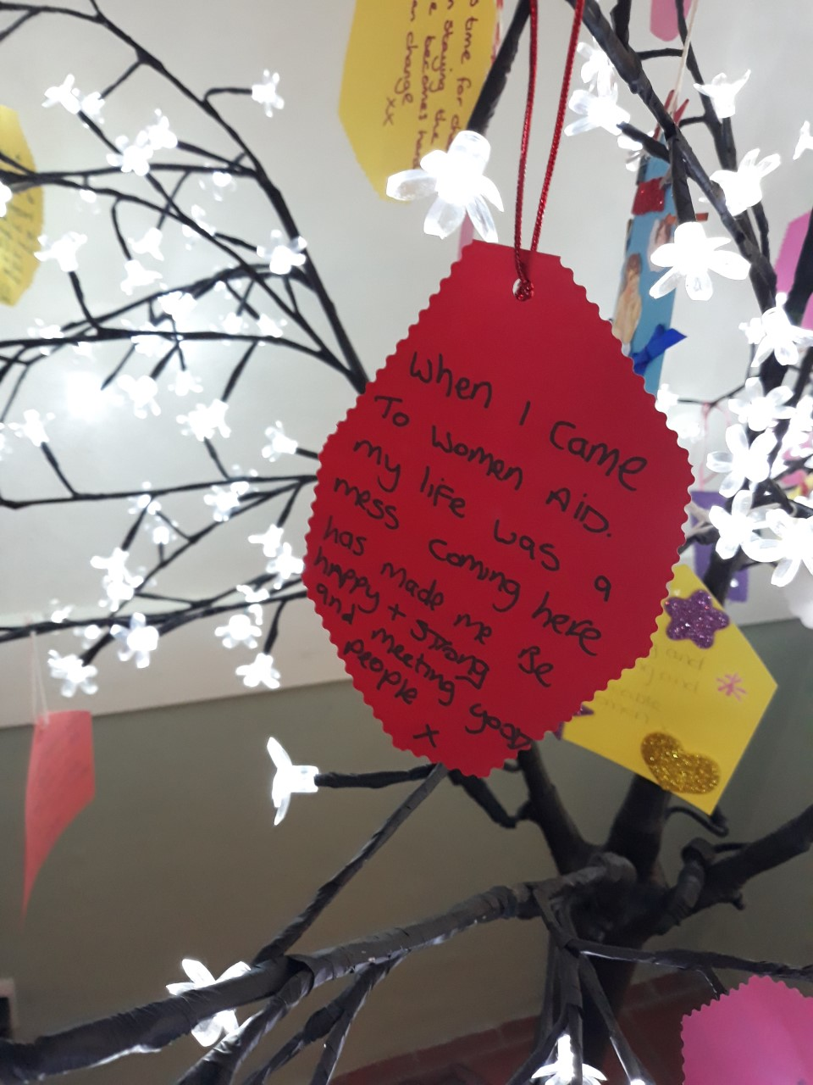

Consistent with the International Women’s Day theme EachforEqual, we also invited our service users to replicate the ‘equals’ sign which represented that each one of us can contribute to an equal world.

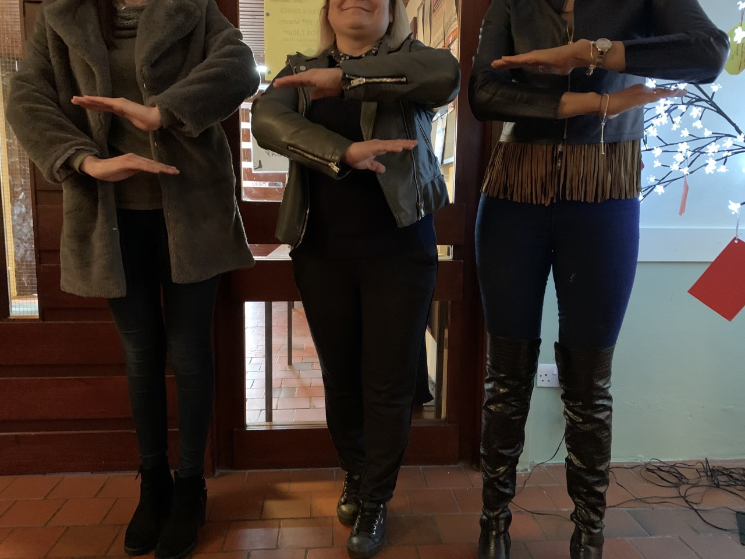

It has been truly rewarding to see the journey our service users have gone through with GEWA. Despite some challenges, we demonstrate resilience and work collaboratively in adverse situations. We look forward to continuing this support and advocate for our service users in the coming year.

CHILDREN’S SERVICE
As ever our year has been eventful. There continues to be an increase in referrals for children and young people requiring therapeutic input to support their recovery from abuse. This has highlighted the growing demand for our service and the value placed on the outcomes for CYP. Our refuge workers are Karen, Tricia and Agnes and our outreach workers are Ali and Marianne with Gemma recently returning from maternity leave.

SUMMER PROGRAMME
HEALTHY RELATIONSHIPS. The first group was delivered in the forum of a summer activities group. It was delivered over a 6-week period during the summer school break. The aim for the group was to promote Healthy Bodies and Healthy Minds and how growth and change is a natural part of life. This was done using a variety of activities and using healthy foods. The final session was a summer party and local restaurants donated food for the occasion.
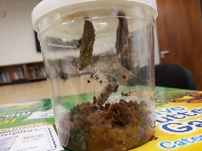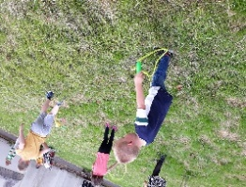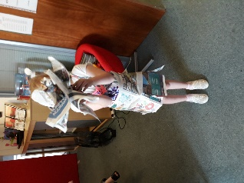
We continue place great importance in our partnership working and have delivered workshops in Healthy Relationships to a variety of organisations. As a result of guest speaking at a fundraising charity event we were given pantomime tickets for all of the CYP and their families. Some of the CYP were invited on stage to take part in a scene and met the actors.
Three successful funding bids enabled us to facilitate outings to Blair Drummond Safari Park, a Halloween Party, and a Christmas day out to M&D’s Christmas experience. This made a huge impact on families to be able to experience fun time together without worrying about how this would be funded and what would need to be sacrificed in order to afford it.
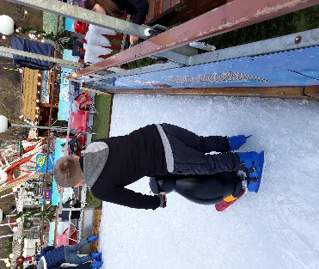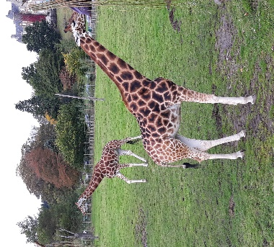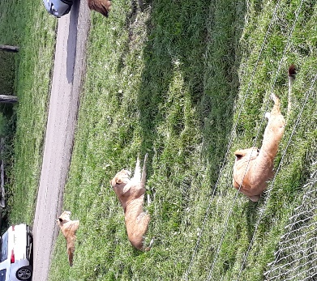

FEEDBACK INCLUDED
We had an amazing time as a family, the kids loved the ice skating and I even tried it myself.
We loved the Safari Park and the kids loved the face painting and the slide.
I really loved the animals the best in the whole world

We offer a holistic approach to our practice and as such secured the services of a Clyde 1 DJ to work with CYP, using music to create emotional playlists personal to the CYP. We have since been invited to work in collaboration with Cassie on other projects.

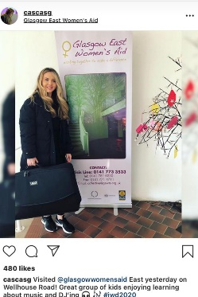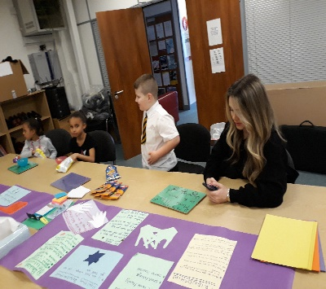

CHILDREN’S CLUB
The service we provide is a safe stimulating environment which encourages all children to interact and provide input and bring ideas and interests to the club. The support that we offer is activity based using a range of age appropriate tools and activities such as arts and crafts, cooking, outings and group work. An important part of therapeutic support is to offer opportunities that will build social inclusion and build relationships within the community.
We incorporate various cultures, festivals and seasons in our activity programme. With that in mind we have provided trips to the supermarket for snacks or for food that we will then cook when celebrating various cultural experiences. We explore activities in our local community such as visiting local parks and the library and outdoor play in club garden. We also visit our local McDonalds and have country walks round local parks over the year and discuss the changes in season, linking this to positive change in our lives.
We promote participation and consultation with CYP while planning our events and sessions encourage feedback from the children which has always been positive and evidences the value of encouraging the CYP participation in service development while having fun.
The activities provide a safe environment for the CYP to build healthy relationships and friendships while living in refuge with others who have had similar experiences and therefore understand what has brought the family to refuge.
Our achievements include confidence building, build self-esteem, trust, positive interaction with other children and adults, and building a sense of achievement through completing VIP (feelings) workbooks and baking.

REFUGE
The ongoing shortage of refuge accommodation for families fleeing domestic abuse has once again been hitting the headlines. Sadly, this has been a common theme for several years. Austerity cuts and the continued lack of social housing continue to deprive us of the opportunity to acquire much needed additional accommodation. We are always full and have to turn women away.
This year we were fortunate enough to secure funding through the Tampon Tax for a refuge-based therapist, Louise.
This is a first for us and it’s been a fantastic service. The service which includes massage and Reiki is for children and young people as well as woman.
This is a therapeutic tool which was previously only available to women through the main office and doing this family work is helping rebuild the bonds of trust within the families.
Once again, we would like to thank our local housing association who continue to support us to provide safe self-contained refuge accommodation

FAMILY DEVELOPMENT SERVICE
The Family Development Service has been running at GEWA for over five years. Current funding for the programme is provided by The Henry Smith project. Our Family Development worker Louise is committed to delivering the best possible support to families who have been affected by domestic abuse.

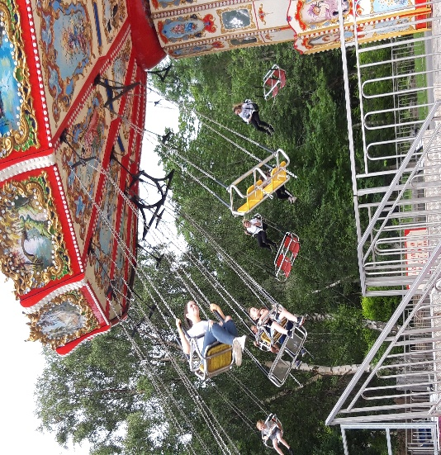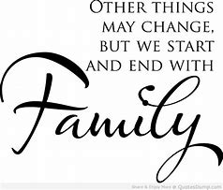

Family dynamics change significantly after living in an abusive situation, resulting in the breakdown of attachment bonds which has a detrimental effect on relationships, with this comes a lack of structure, routine and boundaries are often lost.
Providing a holistic, needs-led support service to families experiencing or who have experienced domestic abuse, enables resolving many issues of emotional trauma, stress and loss. This can involve practical support, advocacy support throughout court and child protection procedures and education around DA and its impact on each member of the family unit
Designing and implementing individual care plans according to the needs of each family is an integral part of the service as is providing outreach support and activities, in addition to our office-based provision.
The service strives to ensure that each family will leave feeling a sense of safety, wellbeing and increased confidence allowing them to move on with their lives in a positive direction. The family service is an essential part of the recovery from domestic abuse for women and their children.

Domestic Abuse Family Financial Support
The main work during this past year has been supporting women, either for one off or ongoing emotional and or financial support sessions. This includes financial health checks & ensuring that the women are in receipt of all their entitlements, helping with new or problematic applications for benefits, applications to the Scottish Welfare Fund, (SWF) and other charities, for example, Glasgow Care Foundation, and representation at tribunals. It also includes budgeting, debt and healthy eating advice where appropriate. During this period, 30 women & their children (29) saw an increase in their annual income through benefits uptake and other help received such as SWF payments and also household goods awarded, the amount across these families for this period is £64,615 gained. Two women were successfully represented at DWP Tribunals and had their benefits reinstated, whilst another woman had her benefits reinstated following a complaint by the worker, she received £4,700 back dated benefits which had been wrongly cut. This particular woman has very poor mental health due to upwards of 30 years severe abuse and has said to us, ‘If you had not supported me, I might not be here, I could not have dealt with this on my own’. It meant a lot to her to have someone on her side for this very difficult period. Due to the expected downturn to the UK economy following the Covid19 crisis it is anticipated, sadly, that many more women will be seeking our service and will be requiring financial and all round support.

SURVIVOR, TRAUMA, ABUSE, ADDICTIONS RECOVERY WORKER
The STAAR worker’s primary focus was the women she would be supporting. With this at the fore, the STAAR worker gave careful consideration on how best to create and implement a robust, person-centered, bespoke service in order to address the complex needs of women experiencing co-occurring domestic abuse/substance misuse issues.
As a result of the successful marketing drive there have been numerous opportunities for networking and awareness raising sessions. This has supported the STAAR Worker to establish strong working relationships with professionals from a range of disciplines. These include social work, health, education, housing, addiction services and other voluntary agencies. The STAAR service has built a credible reputation within the network and is regularly cited at monthly Multi-Agency Risk Assessment Conferences (MARAC). The primary focus of the MARAC is to safeguard the adult survivor and where necessary their children and draw up an action plan to help manage that risk. This highlights the dangerously high level of risk experienced by service users who are now prioritised and supported by the STAAR service having created this vital referral pathway.
The STAAR project has had an overwhelmingly positive response from our partner agencies, who have noted the correlation between domestic abuse and substance misuse with positive feedback on outcomes for women they referred. Professionals and service users have reiterated the desperate need within the local area for a bespoke service to best support women who experience both. This is reflected in the number of referrals and the growing waiting list. A local housing organisation and The Scottish Drugs Forum have
included our service in their directory/newsletters, which again evidences both the need and reputation of service in its first year.

Having consulted with service users in focus groups we co-facilitated two groups which were positive parenting approach and holistic therapy. Many survivors say that their physical wounds heal, but the emotional and psychological damage far outlasts the relationship.
Many women who have/are experiencing domestic abuse can relate to holistic approaches in the healing process. It was widely acknowledged and recognized, that being a parent and

parenting effectively when living with or fleeing co-occurring domestic abuse and addictions is an enormous task and one that causes significant stress and anxiety.
Holistic Group-The group was being carried out over a 10-week period for 2.5 hours per session however not completed due to the COVID-19. The holistic therapist will revisit the
session before the break before proceeding with the remaining sessions. There are 14 women in the group and to date there was 100% attendance.

Parenting Group 8 weeks in collaboration with Glasgow Kelvin college and provided by Parenting Network Scotland and option of completing their college work which then will provide them with an SVQ certificate, and a guaranteed interview should they wish to go back into education.

COMPLIMENTARY THERAPIES

Our therapist provides a range of complementary therapies to help alleviate the symptoms of long-term health conditions, boost self-esteem, increase confidence and enable clients to take more control of their decisions and make positive life choices.

Therapies offered include...

Massage to help induce relaxation, increase energy levels, and reduce the negative effects of stress while promoting positive health and wellbeing. During treatment, the client will be covered and only the part of the body I am working on will be exposed.

Facial massage which brings about a reflex response from the sensory nerve endings, this helps to reduce stress and relieve psychological distress.

Hand & Nail manicures to boost circulation and increase blood flow around the body to improve joint mobility, relieve aches and pains, nourish, and hydrate the skin.

Reflexology which works on the principles that there are "reflex" points in the feet which correspond to the various parts of the body, pressure is applied using specific thumb, finger and hand techniques that centre on the flow of energy along pathways within the body, this helps to calm the central nervous system and promote relaxation.

Reiki, meaning "Universal Life Energy” assists in the body's natural healing processes, induces deep relaxation, helps clients cope with difficulties, relieves emotional stress, and

improves overall wellbeing. During treatment, the client will remain fully clothed and be covered over with a blanket.

Finance

Overall, we were very fortunate with funding in 2019/20. For that, staff and service users are truly grateful. For each pound generated it makes a difference to someone’s life.

We retained funding at the same level as previous years from Glasgow City Council via the Integrated Grants Fund, Grants to Voluntary Organisations. Likewise, with the funding from Glasgow City Council that is specifically for running our refuge. These funds are mainly to provide our women’s services with some of the cost of office staff. We continually have a waiting list for our direct support services for women and for Refuge provision. We are always looking at ways of increasing income to offer our services to the maximum number of people.

However, as we leave the year things are far more uncertain as the Council are replacing IGF with a new more inclusive Glasgow Communities Fund. The council had planned on this starting on 1st of April 2020, however due to unforeseen circumstances this did not happen and as such, existing levels of funding from IGF has been extended to 30.9.2020. We will await decisions in the new financial year. This unfortunately puts an additional strain on staff as we have no security.

The Scottish Government continued to fund our Multi Agency Worker and our Children’s service. These are both incredibly important services one offering support to the most vulnerable children and young people when they need it most. The other with a voice and a strategic overview of all Domestic Abuse related information thus allowing GEWA to be part of the “bigger picture.”

We secured funding again from The Robertson Trust to part fund our family financial advice service worker. This Part funding is secure for 3 years. The remainder of funding for this post was provided by The Royal Bank of Scotland, Skills & Opportunities Fund and the Bank of Scotland Foundation. Both funds were for a year. However, when Bank of Scotland ended, they called us to offer an additional £3000 as they liked what had been achieved with our original award from them. Great news.

We had continued funding from Comic Relief to provide a service to women affected by addictions. This service is established now and continues to see referrals coming in, and women receiving a service that was severely lacking.

Tampon Tax has allowed the start-up of a Therapist weekly for women who are or have been housed in refuge. This is proving very popular and beneficial to the women accessing this. As this fund ends, workers are actively seeking alternative funding to keep the programme going.

The Henry Smith Charity is funding a Family Development worker for 3 years. This service is hugely beneficial to the “family” as a whole and allows the family to repair in a safe and healthy environment.

Unfortunately, our collaboration with the Glasgow Together Consortium came to an end. We thank everyone involved in that venture.

We would like to thank everyone for all the additional amounts of money donated to GEWA, as I stated at the start of this, every donation makes a difference. We cannot provide services without funding. The additional monies that individuals donate allows us to put the icing on the cake, as it were, to do all the nice things that we otherwise would not be able to do. For that we are truly grateful to every one of you and all our incredible Funders.

https://www.bbc.co.uk/news/uk-52157620

